81tKRETWAT DEWAN PIRWAKILAN RAKYAT uAEaAB

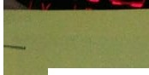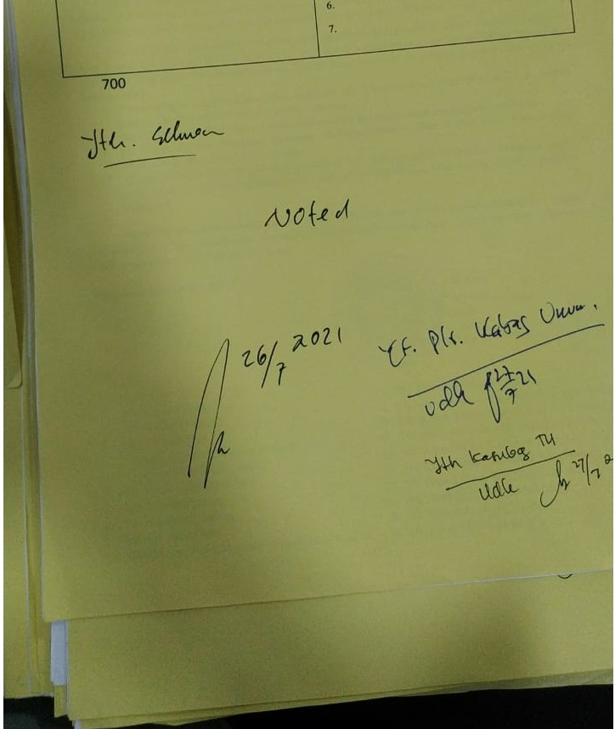

-

KOTA MA.LANG

LEMBAR DISPOSISI

|  |  |
| --- | --- |
|  | |
| Tlftlllll *ff1* Jllll 2t2I | 21 Jull 20ll  Index |
|  | Kode |
|  |  |
|  | 1. Vlb Kewa DPRD Koll Mallnl  2.  3.  4.  s. |



 

